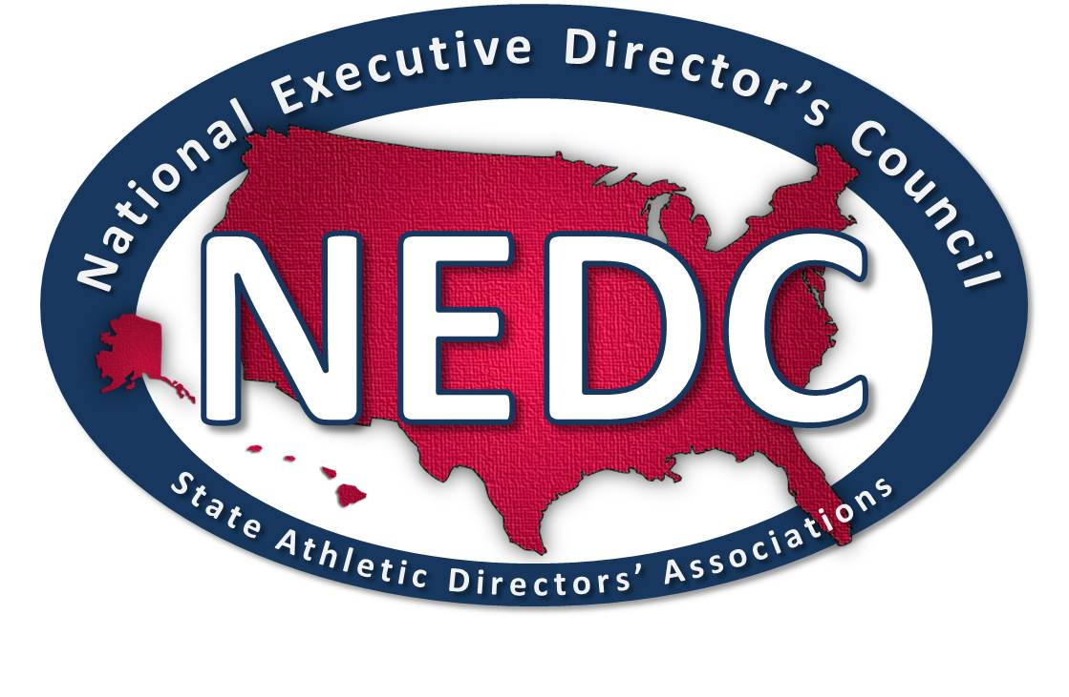
Welcome to Ohio and the 2019 Summer NEDC Meeting!!
Registration Form

On behalf of the membership of the Ohio Interscholastic Athletic Administrators’ Association, the Ohio High School Athletic Association and Section 2 of the NIAAA, we are pleased to bring the summer meeting and the members of the NEDC to the Buckeye State for the FIRST time!
The dates for the summer meeting are Tuesday, July 23 through Friday, July 26. The meetings will be held in the Courtyard by Marriott in Canton, Ohio. To book your room you will have two options: 1) either phone (330) 494-6494 and simply mention “NEDC/OIAAA Summer Conf”, or 2) online registration: http://nedc.us/Canton2019.pdf) and scroll down to “TO BOOK CLICK HERE” . Rooms are $119/night, single/double, and rates are good for Monday, July 22 through Friday night. Lastly, if you wish to book beyond Friday night, you will have to call in your registration. NOTE: The 2019 Pro Football Hall of Fame Week is July 29-August 4.
We have negotiated the conference rate of $119 for one day prior, and two days after the conference for those who wish to extend the trip. For planning purposes please plan on being to the hotel by 4:00 pm on the 23rd so you may enjoy our welcome activity. Registration will open at 2:00 pm to 5:00 pm on Tuesday, July 23rd.

Transportation for the conference is convenient. If flying into Canton (CAK) or Cleveland (CLE), you can rent a car and drive (10 minutes from CAK or 75 minutes from CLE) south on I-77 and exit on Everhart Rd. Take a right and then another IMMEDIATE RIGHT and follow the drive back to the Courtyard by Marriott and the hotel (parking is free). The same directions apply for driving in on your own. The hotel does provide a complimentary shuttle to and from CAK.

We will be finalizing the agenda for the Summer Summit agenda by March 1st. We expect to have an exciting and beneficial schedule of professional development and discussion. Additionally, we are arranging for some very interesting activities for the membership and spouses.

Registration for the 2019 Summer Summit is $150.00 for the NEDC member and $50.00 for a spouse/significant other. Please fill out this form and mail it back along with a check made out to the NEDC to: Fred Balsamo, 30 Realty Drive, Cheshire, CT 06410

NEDC Member Attending at $150_______________________________________

State ______ Polo shirt Size ______ Cell Phone __________________________

Spouse/Significant Other Name at $50.00:________________________________

Please indicate any special dietary restrictions that need to be considered in meal planning:

More information will be forthcoming as we get closer to our event and will include a more detailed agenda and list of activities. Place the dates on your calendar now.

If you have any questions, feel free to email or call:
Bruce Brown: oiaaa.brucebrown@gmail.com, 330-352-9848
Fred Balsamo: fbalsamo@casciac.org, 203-605-0553

We would ask that members please register as early as possible to allow us adequate time and information to plan our schedule of events. Knowing our meal “numbers” and appropriate number of conference packets well in advance allows us to provide the best and most cost-effective experience for our NEDC group. Thank you for your support and involvement with our great organization.
FOR NEDC USE ONLY
Amount enclosed -___________ Check Number- ____________ Date Received -_____________

